Initial settings: Add a User, Network Settings, Change to static IP address, Disable IPv6 if not needed, Configure Service, display the list of services which are running. Stop and turn OFF auto-start setting for a service if you don’t need it, Sudo Settings

Add user :-

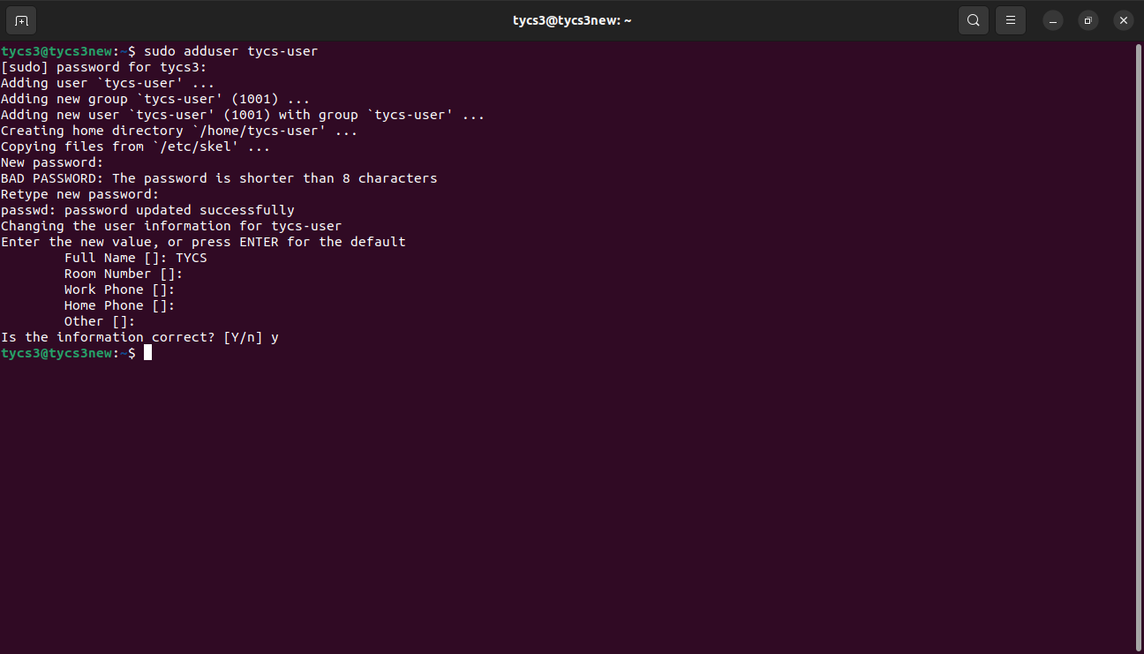

Disable IPv6 if not needed 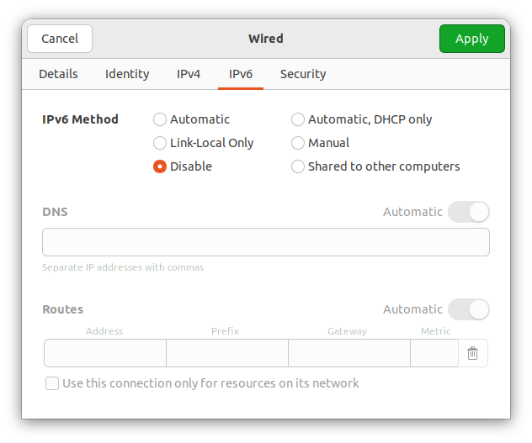

Change to static IP address

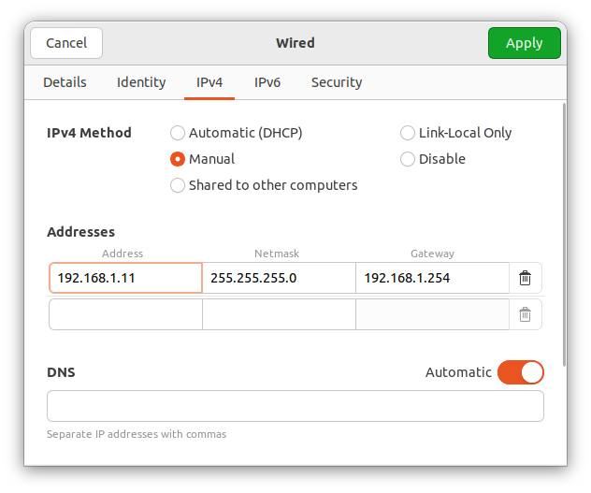

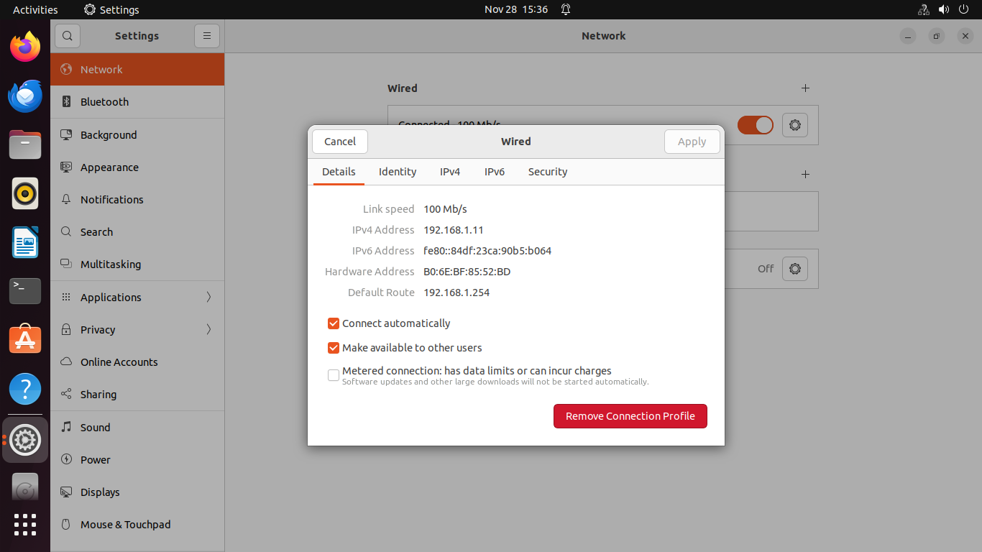

List of services :-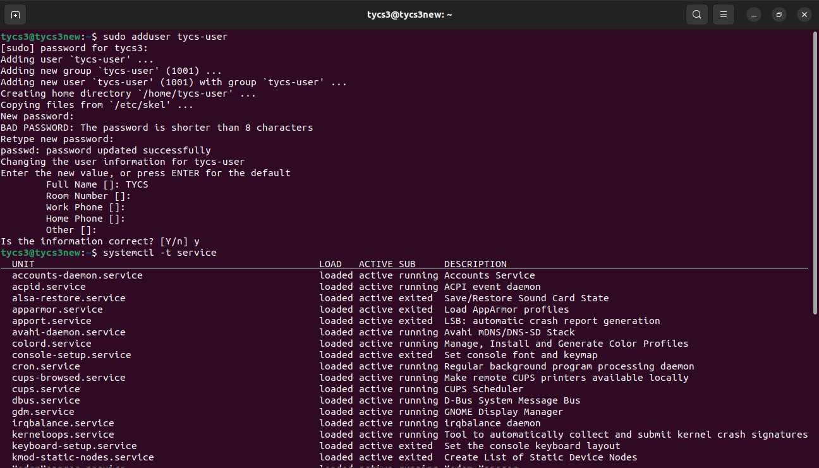

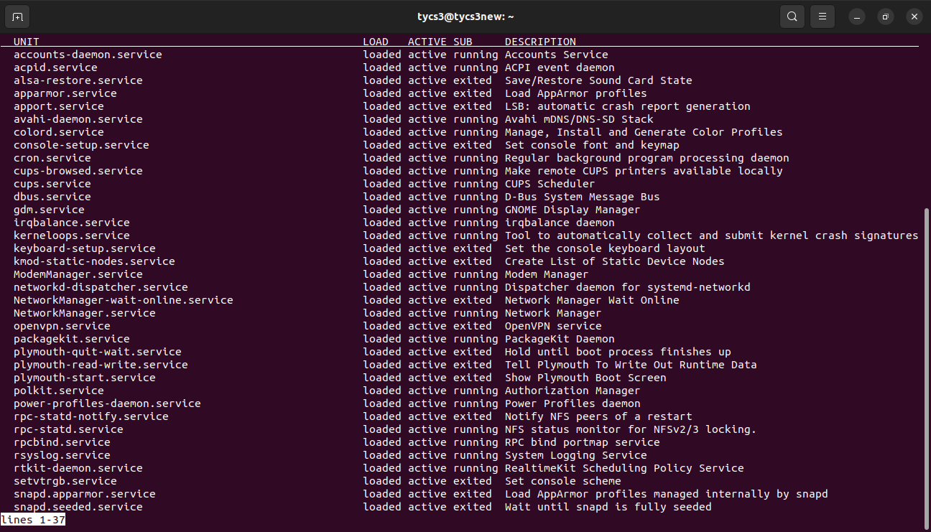

Stop the service :-

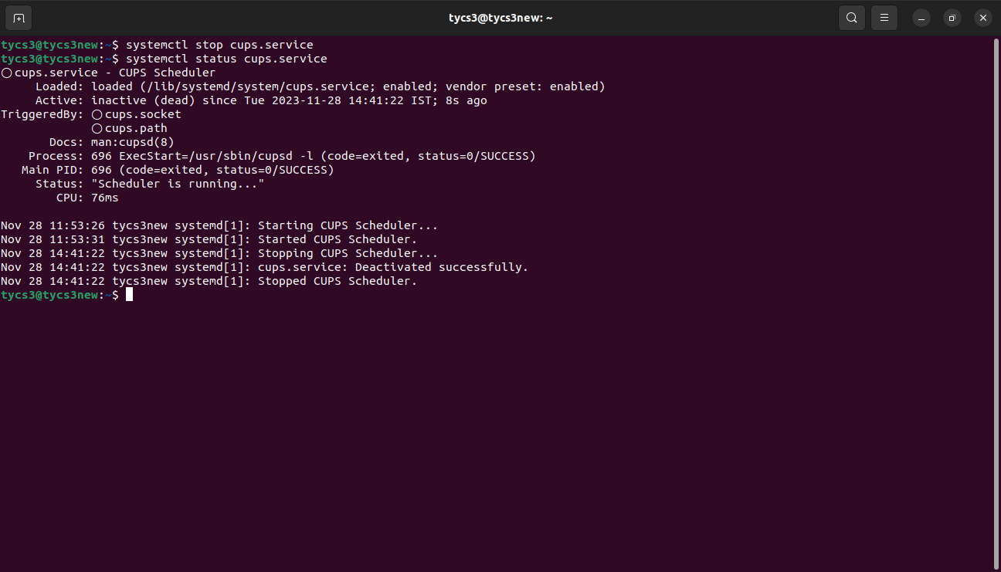

Disable the service :-

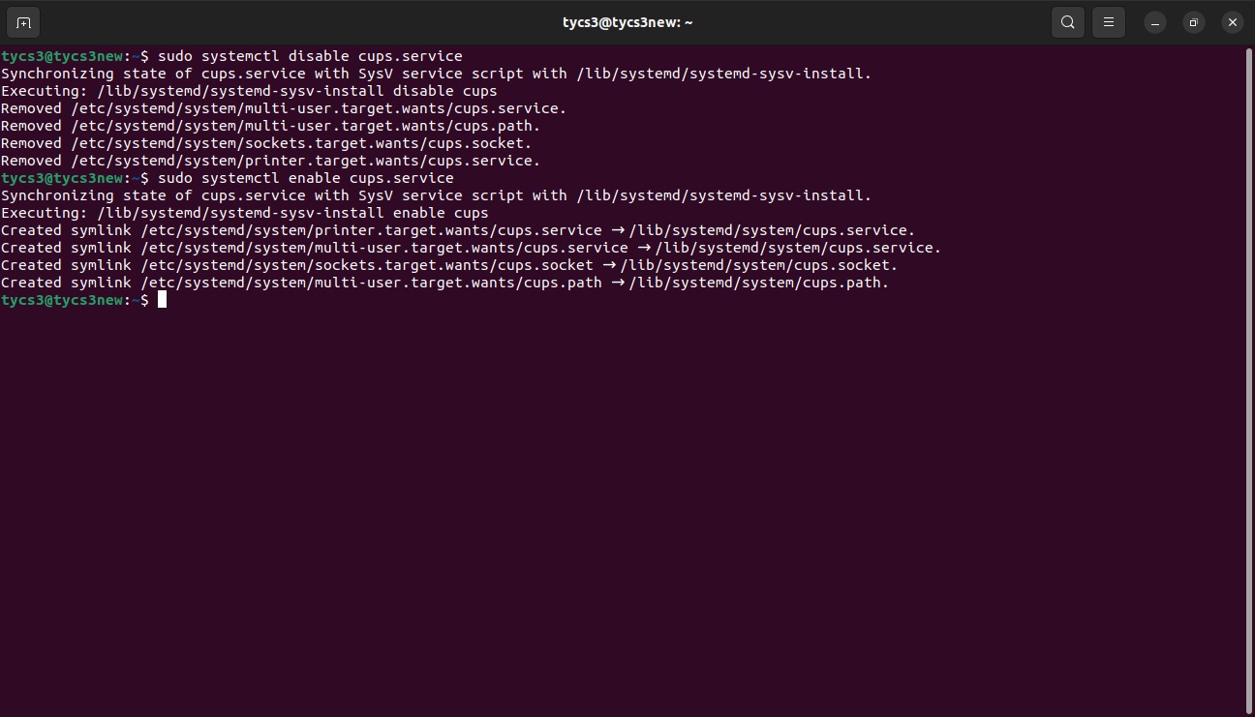

Sudo setting :-

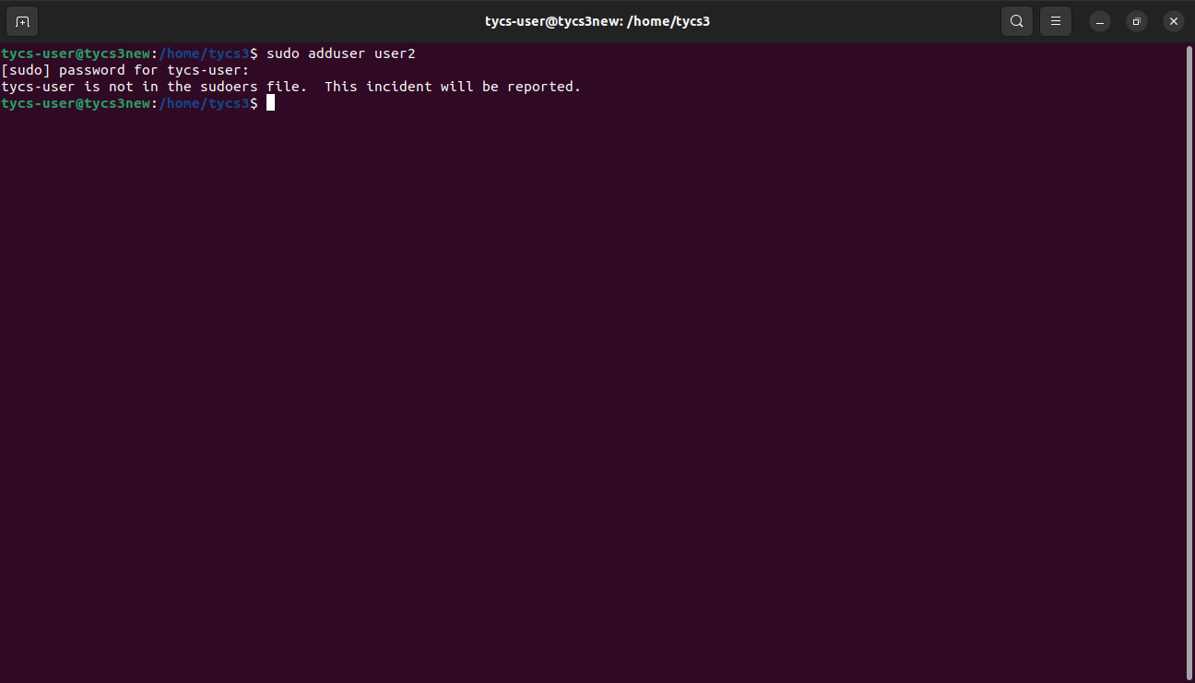

Add the new user in /etc/sudoers fike :-

